An “Expanded Manual” for the Behringer Pro VS Mini
Software version 2.0.2

Taken from a variety of internet sources, this manual attempts fill in some of the information missing from the manual.

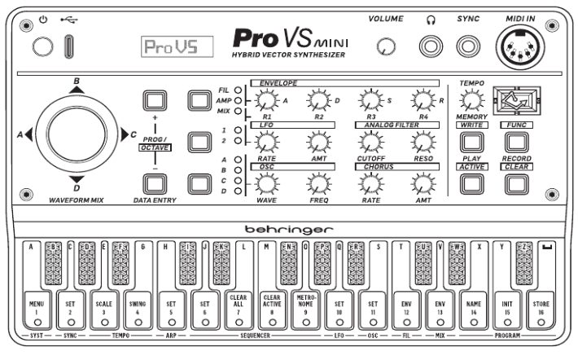
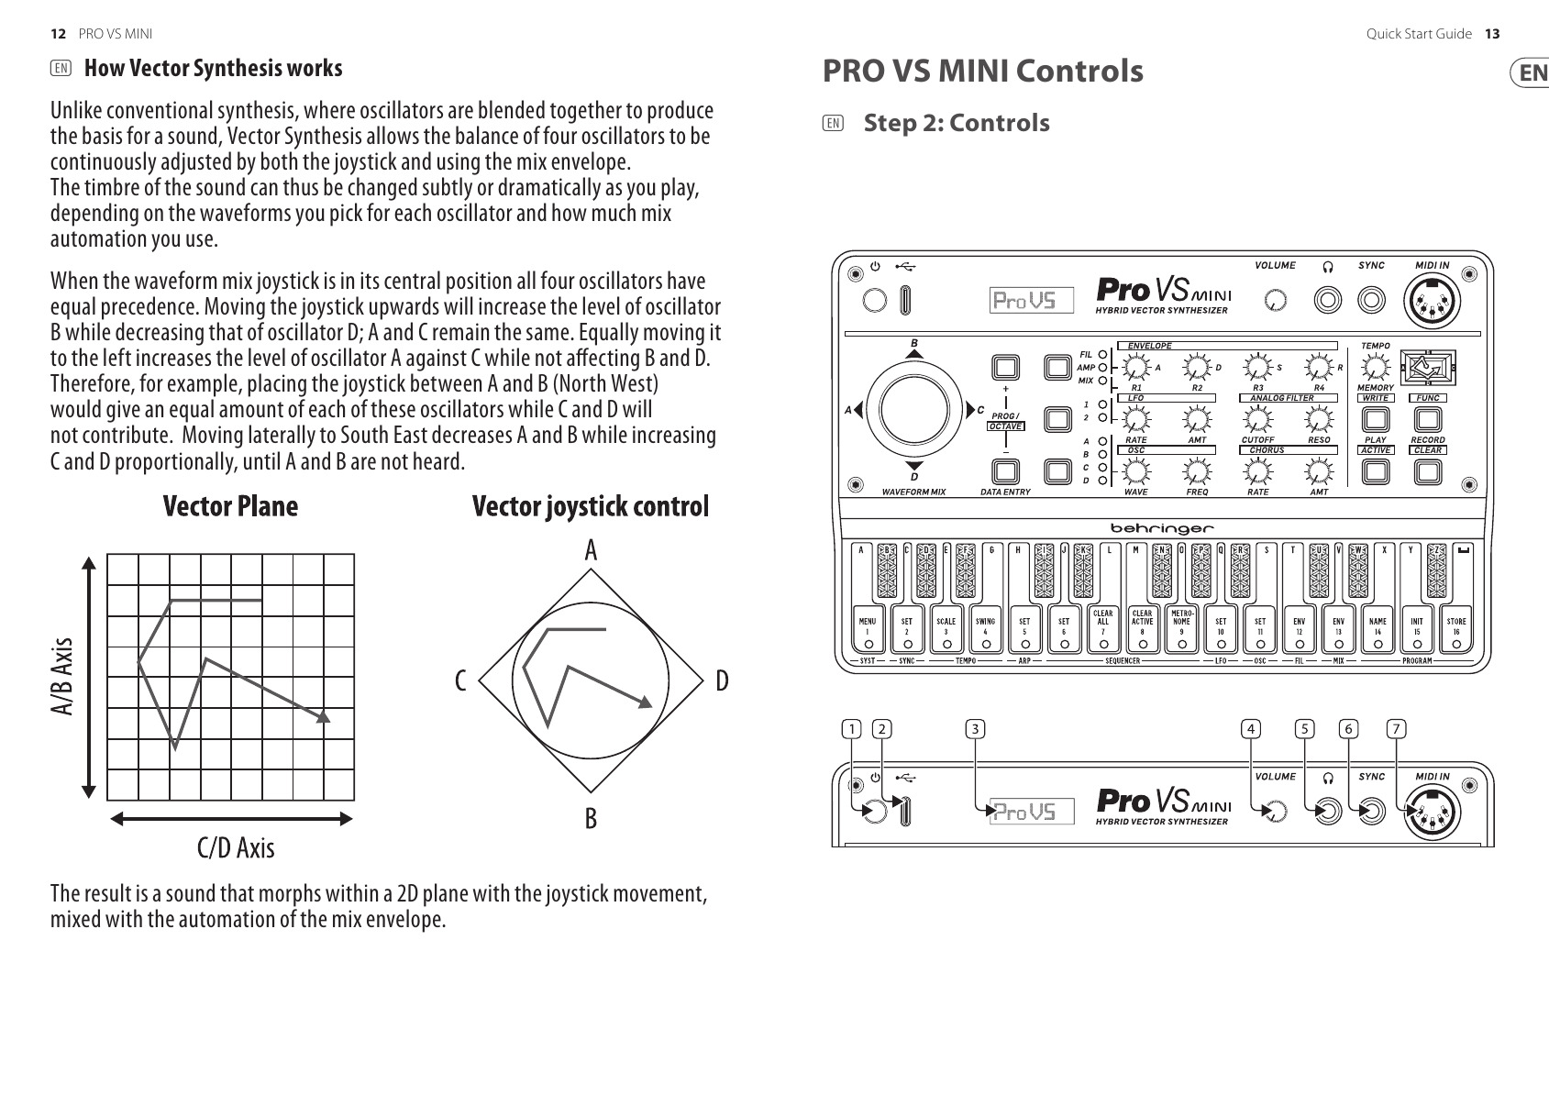
THESE DRAWINGS ARE INCORRECT. The axes are A/C and B/D

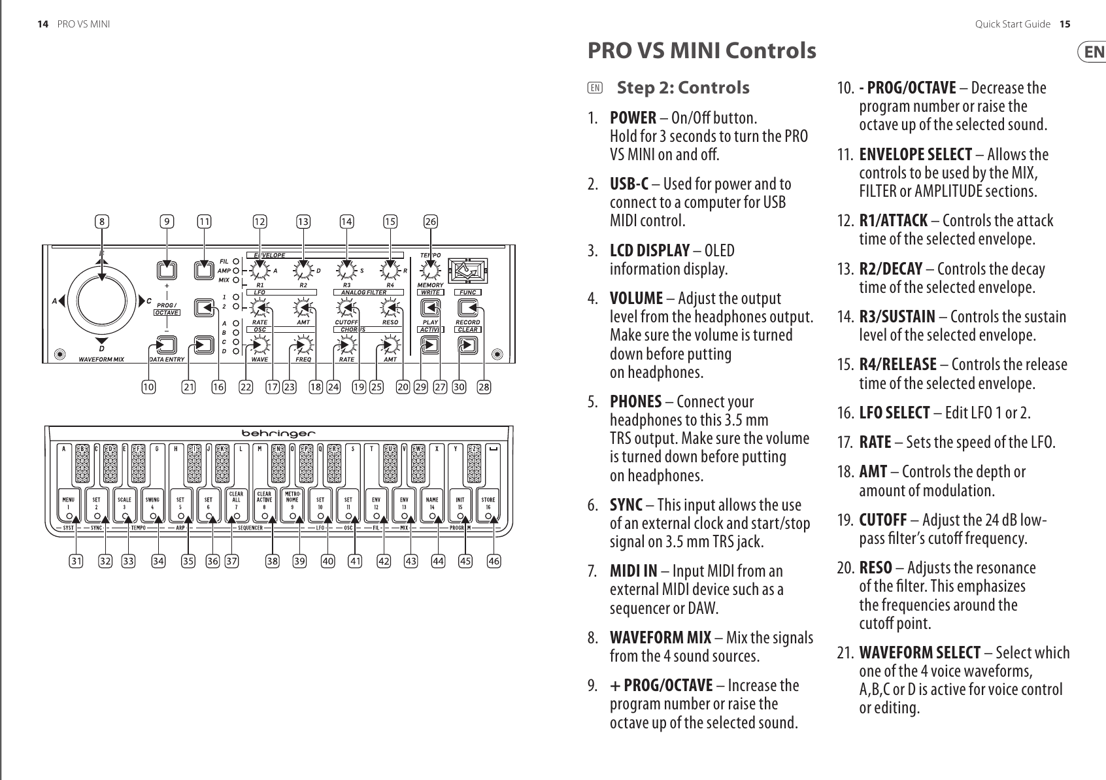
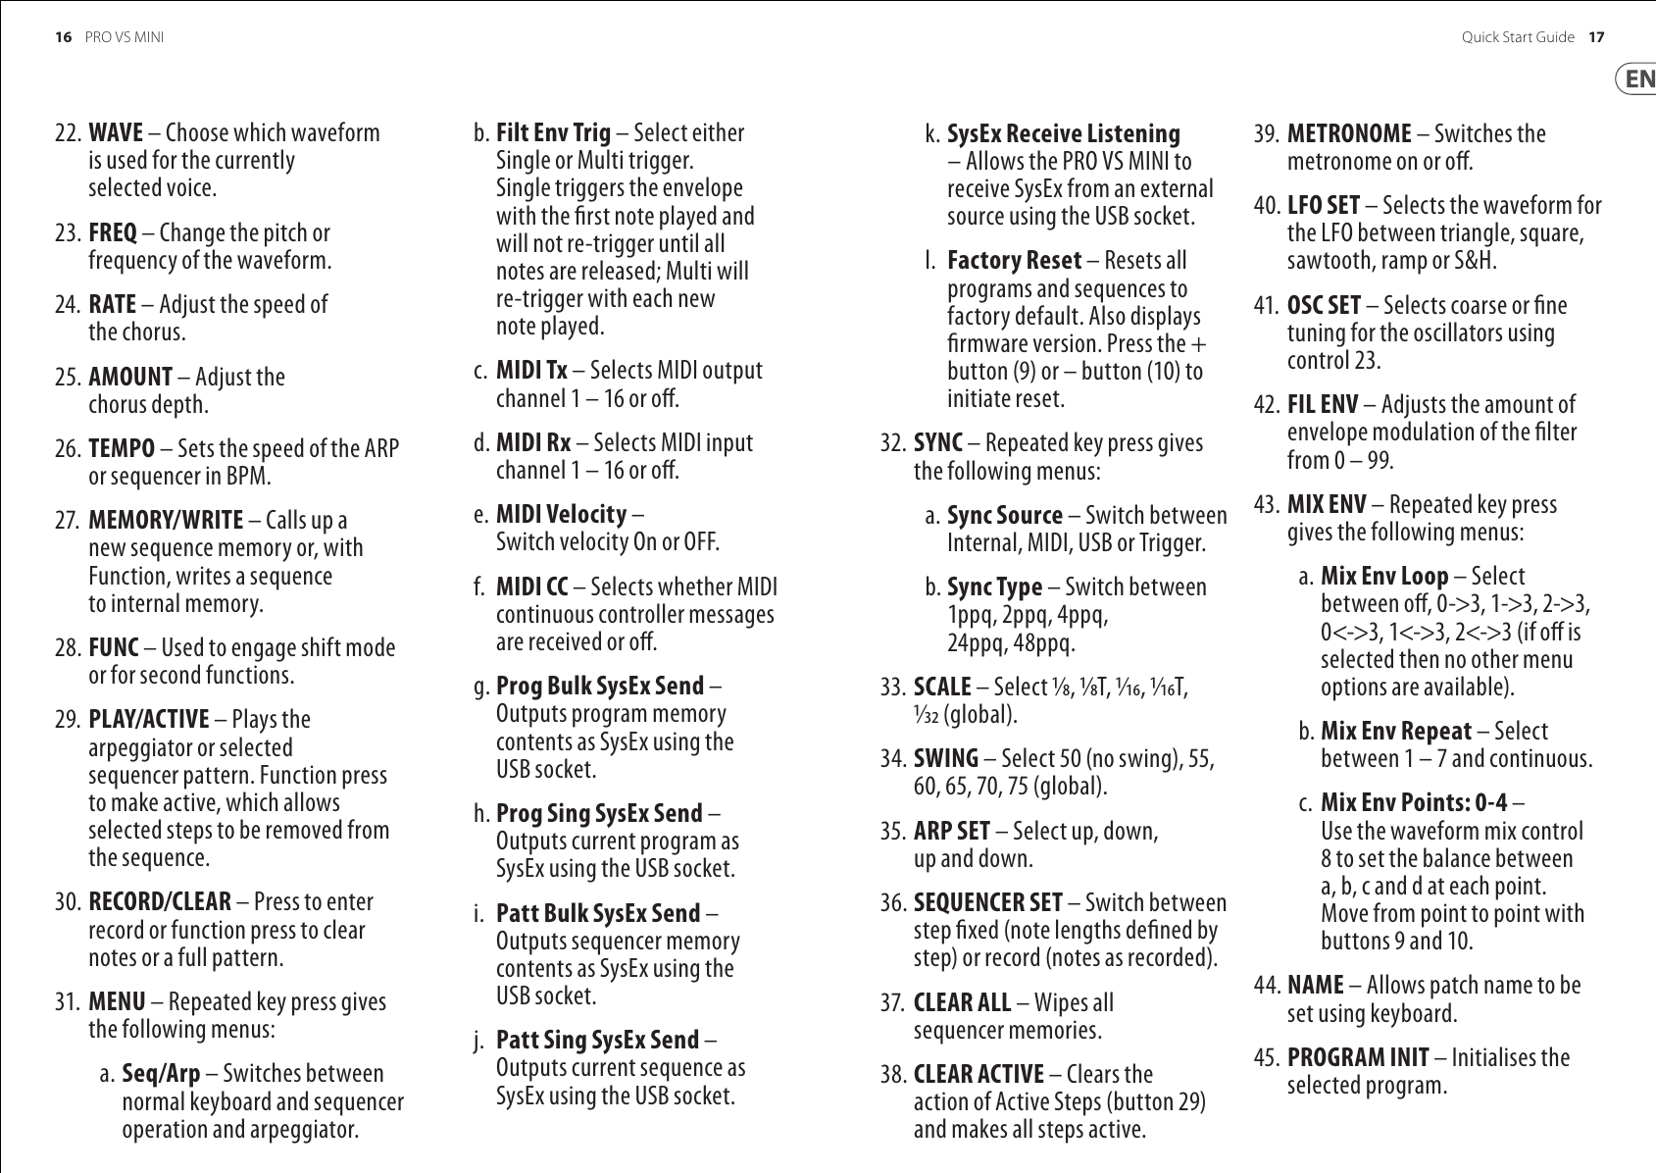
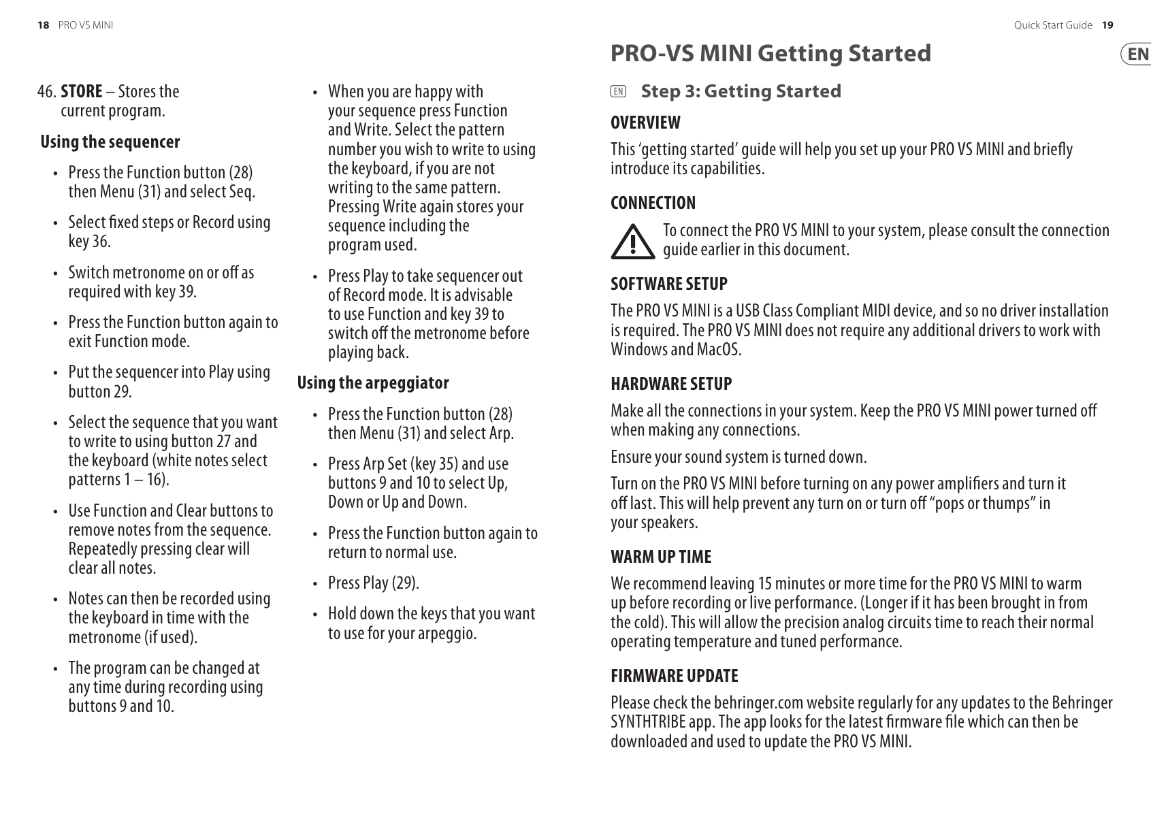
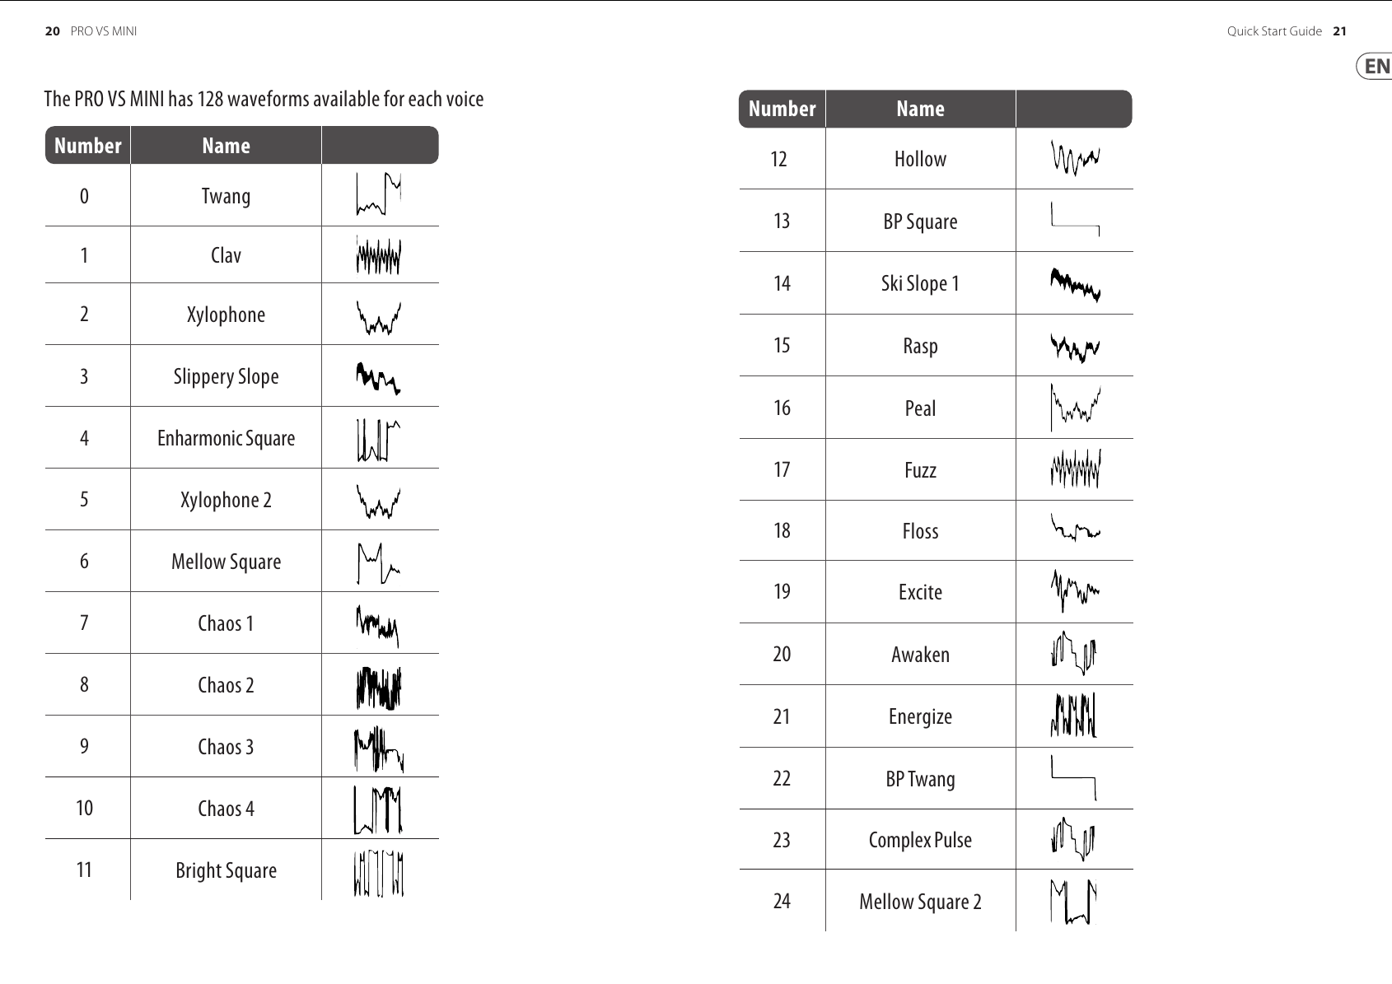
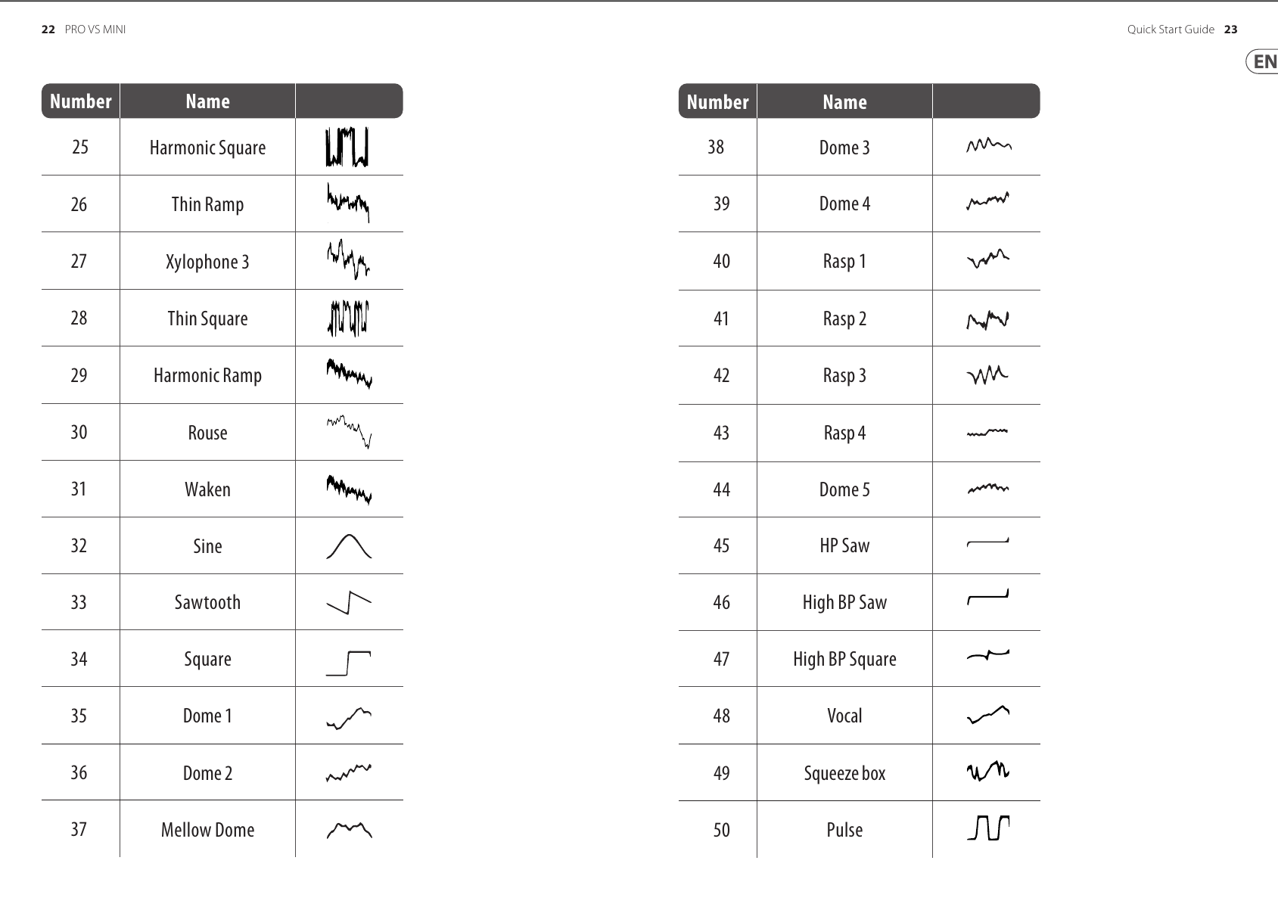
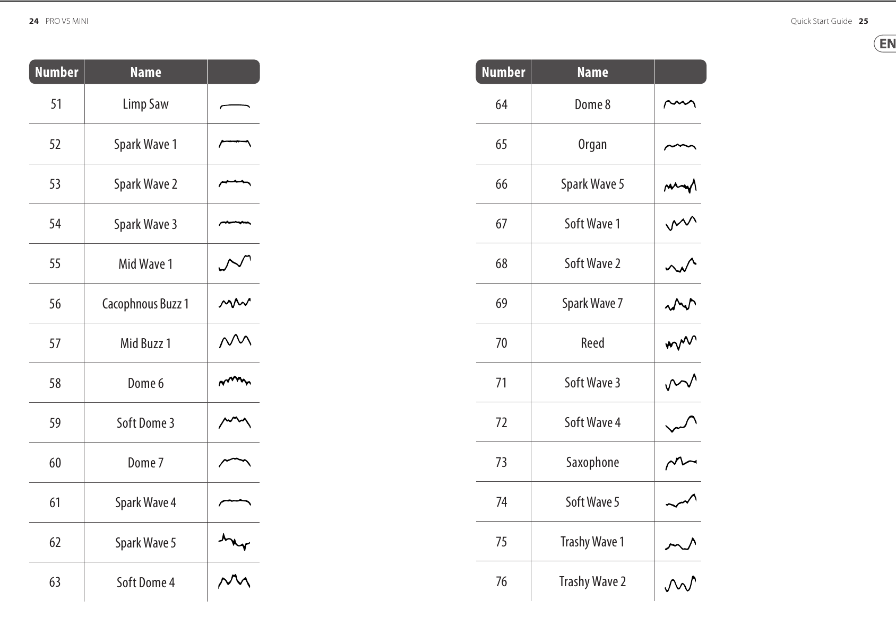
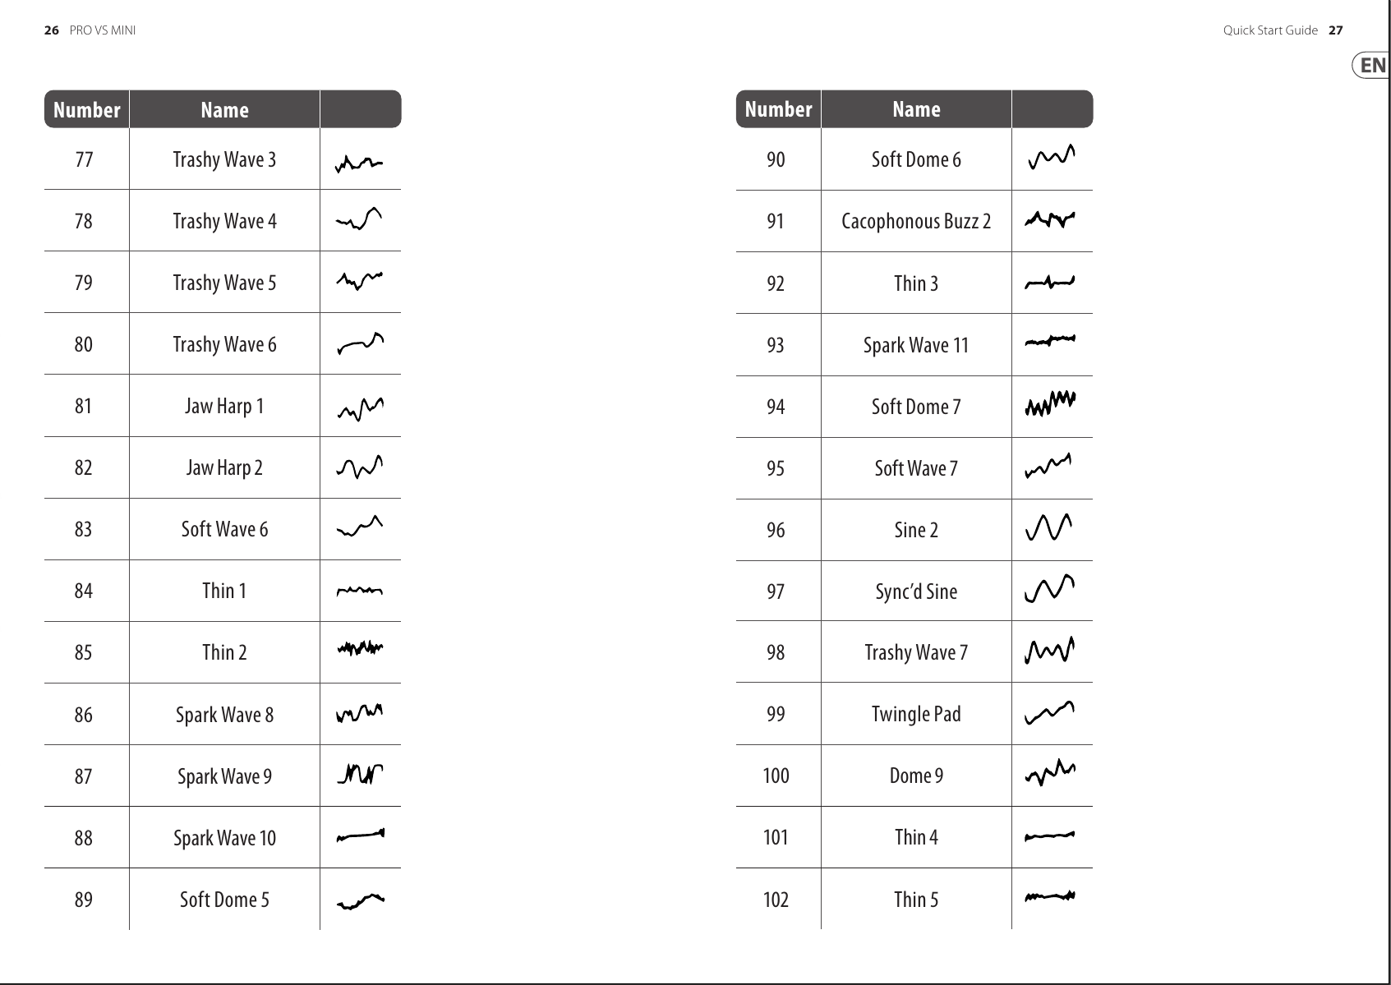
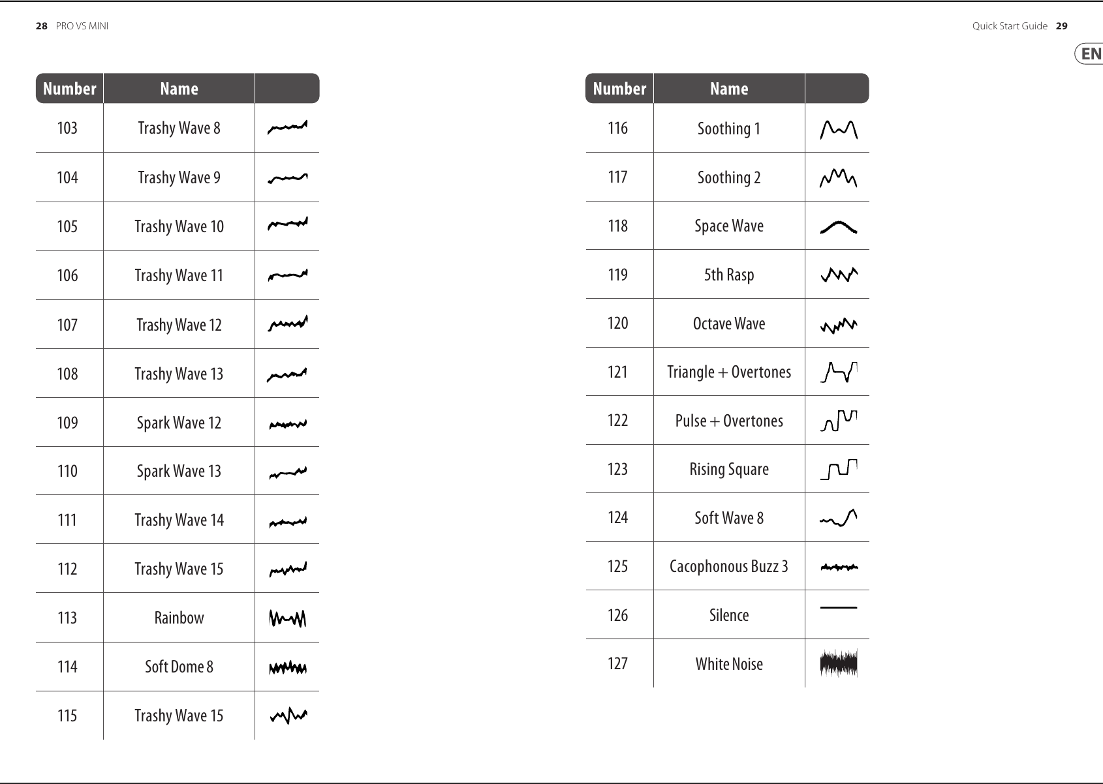

Pro VS mini Block Diagram

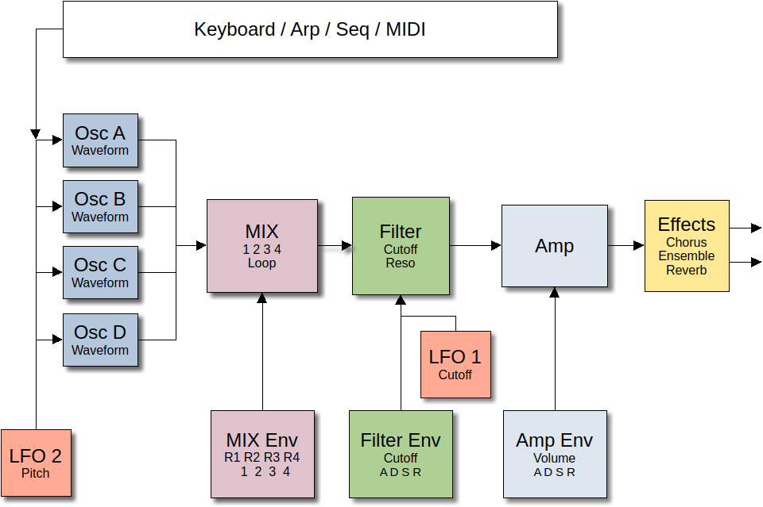

This section covers which controls affect which blocks, and how to modify them. I’ll use the same button numbers as the Behringer front panel diagrams at the start of this document.

Oscillators A-D | - Encoder 22 selects the wave shape, while pot 23 (Freq) controls the tuning. You can adjust them blindly or press the oscillator select button 21 to display the wave number and tuning offset. Press button 21 again to cycle through all four oscillators. The display will show something like 000 | 00.00. The left number is the wave number. The right number is the tuning controlled by the Freq pot.  - The waves are documented graphically above. Two waves of note are wave 126 – Silence, and wave 127 – White noise.  - The amount by which the Freq pot changes the oscillator can be “Coarse” which changes the pitch by a simitone, or “Fine” which changes the pitch by cents. Whether this control is in Coarse or Fine mode is controlled by “Oscillator Set”.  - To get to the Osc Set function, press the “Func” button (28) then “Osc Set” (button 41 on the diagram, labeled “11” on the keyboard). Repeatedly pressing the Osc Set b utton cycles through various oscillator settings. One of them is “Osc Frequency” which sets the function (Coarse or Fine) of the Freq pot.  - The second function of Osc Set is Poratmento which controls how quickly or slowly the oscillator can change frequency. This control is sometimes called “glide” on other synthesizers. Zero is the fastest, and 31 is the slowest.  - The oscillator pitch is also affected by LFO 2 which will be covered later.
MIX/MIX ENV | The four oscillators are all feeding into a vector mixer. A look at the joystick (control 8) should make it obvious how the mixing works. If you move the joystick while pressing a key, you can control the oscillator mix manually. The real magic of this synth shows up when you automate the motion of the joystick. This automation involves five (5) points numbered 0 through 4. This is MUCH easier if you have an external MIDI keyboard.  - To set the Mix Env points, press Func button (28) followed by the “Mix Env” button (labeled 43 on the diagram and 13 on the keyboard). The fist thing the display will show is “Mix Env Loop” which we’ll get to later. Press the Mix Env button again to see “Mix Env Repeat”, and again to see “Mix Env Point: 0”.  - The cycle looks like this: When you press a key, the sound starts at Mix Env Point 0, followed by Point 1, 2, and 3. It holds at Point 3 until you release the key. When the key is released it will move to Point 4. The speed at which it changes from one point to the next will be explained later.  - Move the joystick to set the starting point of the sound. Usually, this is near oscillator A, but it can be anywhere on the joystick.  - Press the “+” button (9) to move to Mix Point 1, then Mix Points (2,3,4).  - The rate at which the mix moves through the points is controlled by the Mix Envelope. Don’t forget to turn off the Func button. Press button (11) as needed to select the “Mix” envelope. You will see a display showing numbers for “R1 | R2 | R3 | R4”. These are the rates at which the mix moves towards each of the mix points. Use the ADSR pots to adjust each.  - Mix Env looping. Use the Func button then Mix Env (43). The first thing you’ll see is the value “0-> 3”. This means that the envelope will loop through Points 0,1,2,3 then back to 0 some number of times (set later) before holding at Point 3 until the key is released. You can use the “+” key to change this setting through various loop cycles. Some of the have a notation like “0<->3”. The loop cycle is 0,1,2,3,2,1,0… until holding at 3 for the release. There is also an “Off” setting.  - Pressing the Mix Env button again will take you to “Mix Env Repeat”. This can be set from 1 through 7 loops, as well as continuous looping.  - It is important to understand the looping behavior. In a loop like 0->3, it loops through positions 0, 1, 2, 3, 0… Notice the 3 to 0 transition, and understand that there is no “rate” (delay) when the loop recycles, so the jump from 3 back to 0 can cause a significant discontinuity (bump) if these two points are very different. So, if you are going to loop then it makes sense to have the starting point and the point 3 to be pretty close.
FILTER / FILTER ENV | The filter is a simple 24dB low-pass filter. This means that as the Cutoff control (pot 19) is reduced you will hear less of the high frequencies. The Reso[nance] control causes an volume boost of the frequencies near the Cutoff frequency. If you turn this up you get some nice effects, but go too far and the filter will self-oscillate. You may or may not like the result.  - The Cutoff frequency can be controlled by the Fil[ter] envelope. Use the envelope select button (11) to select the “Fil” envelope. Use the ADSR pots to control the filter envelope.  - A[ttack] controls how quickly the filter opens, and D[ecay] controls how quickly it closes to the S[ustain] point. It will remains at the sustain point until you release the key. Then the R[elase] pot controls how quickly the filter closes.  - Conceptually, the Filter Envelope opens the filter (turns up the Cutoff frequency) relative to the cutoff pot (19), so if pot 19 is turned way up, then the envelope cannot have any effect. If you turned the cutoff frequency down and still don’t hear anything changing when you press a key, then the Filter Envelope Amount is set too low: The Filter Envelope Amount is controlled by Func “Fil Env” (button 42 or keyboard 12). The amount varies from 0 (no effect) to 99 (very large effect).
AMP / AMP ENV | This controls the volume contour of the sound. Like the filter envelope, use the envelope select button (11) to select the Amp[litude] envelope, then the ADSR pots to control the volume over time.
EFFECTS | The Pro VS mini has a selection of effects. To control the currently selected effect, use the Rate pot in the Chorus (pot 24) to control effect rate, and the Amt pot (25) to control the effect intensity. When the synth was released it only had a Chorus effect, so the section is named “Chorus”. With the more recent software update, there are additional effects.  - To select the active effect use “Func” “Menu” (button 31 or keyboard 1). You must press it three times to get to the “FX Engine” page. Use the “+” and “-” buttons to choose from Chorus, Ensemble, and Reverb.
LFO 1/2 | The LFOs (Low Frequency Oscillators) can be used to continuously alter the pitch of the oscillators and the cutoff frequency of the filter. LFO 1 affects the filter cutoff frequency, and LFO 2 affects oscillator pitch.  - Use the LFO select button (16) to choose LFO 1 or LFO 2.  - Use the Rate (17) and Amt (18) pots to control the speed and intensity of the effect.  - Each LFO can have different waveforms. You can select between Triangle, Square, Sawtooth, and Ramp. To change the waveform you must first select the LFO, then use “Func” “LFO Set” (button 40 or keyboard 10). Use the +/- buttons to choose the waveform.  - It is worth knowing that LFO 2 amount is also *set* by the MIDI Mod Wheel (CC 1).

Mix Envelope Behavior
There are two basic types of Mix Envelope behavior; looping and non-looping. Non-looping has “Mix Enc Loop” off.
Non-Looping: When a key is pressed it begins at point P0 and moves to P1 in R(ate) 1 time, then to P2 in R2 time, and finally to P3 in R3 time. It will then hold at P3 until the key is released. It then moves to P4 in R4 time. That’s it.

Looping: All loops begin at P0 and end at P3. However, they can loop back to P0, P1, or P2.
0→3 will go through P0, P1, P2, P3, then back to P0, P1, P2, P3, …
1→3 will go through P0, P1, P2, P3, then back to P1, P2, P3, …
2→3 will go through P1, P2, P3, then back to P2, P3, …
On the following reversing loops, the rates operate in reverse as well.
0 ←→ 3 will go through P0, P1, P2, P3, P2, P1, P0, …
1 ←→ 3 will go through P0, P1, P2, P3, P2, P1, P2, P3, P2, P1, …
2 ←→ 3 will go through P0, P1, P2, P3, P2, P3, P2, …

Loops can be set to repeat a set number of times (1-7) before holding at P3, or to repeat continuously.

Because there is no delay between P3 and returning to the start of the loop (P0, P1, or P2) it will sound better if the end point and the loop start point are close together. Otherwise there will be a noticeable discontinuity.

Regardless of where the loop process is, when the key is released the mix envelope will move from WHEREVER it is to P4 in R4 time.
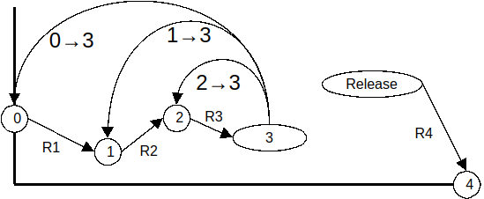

MIDI CC Implementation from https://midi.guide/d/behringer/pro-vs-mini/
and https://deepwiki.com/gabrielinuz/midi-cc-controller/5.1-behringer-pro-vs-mini

Notes:

The Pro VS Mini does not respond to CC7 (Volume)

General
Parameter | CC | Range | Usage | Orientation
Modulation | 1 | [0–127] | — | 0-based
Portamento time | 5 | [0–127] | — | 0-based

FX
Parameter | CC | Range | Usage | Orientation
FX engine | 9 | [0–127] | 0~42: Chorus; 43~84: Ensemble; 85~127: Reverb | 0-based
FX rate | 91 | [0–127] | —
FX amt | 92 | [0–127] | —

Voice wave
Parameter | CC | Range | Usage | Orientation
Voice A | 24 | [0–127] | See list above | 0-based
Voice B | 25 | [0–127] | See list above | 0-based
Voice C | 26 | [0–127] | See list above | 0-based
Voice D | 27 | [0–127] | See list above | 0-based

Voice Tuning
Parameter | CC | Range | Usage | Orientation
Voice A | 111 | [0–127] | Fine Tune (cents) | 0-based
Voice B | 112 | [0–127] | Fine Tune (cents) | 0-based
Voice C | 113 | [0–127] | Fine Tune (cents) | 0-based
Voice D | 114 | [0–127] | Fine Tune (cents) | 0-based
Voice A | 115 | [0–127] | Coarse Tune (semitones) | 0-based
Voice B | 116 | [0–127] | Coarse Tune (semitones) | 0-based
Voice C | 117 | [0–127] | Coarse Tune (semitones) | 0-based
Voice D | 118 | [0–127] | Coarse Tune (semitones) | 0-based

Filter
Parameter | CC | Range | Usage | Orientation
Filter env amount | 47 | [0–127] | — | 0-based
Filter resonance | 71 | [0–127] | — | 0-based
Filter Cutoff | 74 | [0–127] | — | 0-based
Env A | 85 | [0–127] | — | 0-based
Env D | 86 | [0–127] | — | 0-based
Env S | 87 | [0–127] | — | 0-based
Env R | 88 | [0–127] | — | 0-based

Amp
Parameter | CC | Range | Usage | Orientation
Env A | 81 | [0–127] | — | 0-based
Env D | 82 | [0–127] | — | 0-based
Env S | 83 | [0–127] | — | 0-based
Env R | 84 | [0–127] | — | 0-based

LFO
Parameter | CC | Range | Usage | Description | Orientation
LFO 1 waveform | 54 | [0–127] | — | Triangle, square, saw, ramp, s&h | 0-based
LFO 1 amount | 70 | [0–127] | — | — | 0-based
LFO 1 rate | 72 | [0–127] | — | — | 0-based
LFO 2 waveform | 55 | [0–127] | — | Triangle, square, saw, ramp, s&h | 0-based
LFO 2 amount | 28 | [0–127] | — | — | 0-based
LFO 2 rate | 73 | [0–127] | — | —

